Study relation between push and time and length of string to perform operation

This is the results with the order of operand choices changed.

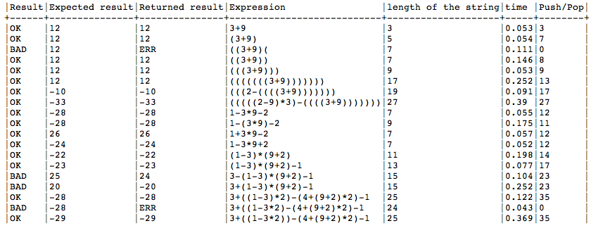
Liste of values with the order or choises changed
from *,/,+,- to +,-,*,/

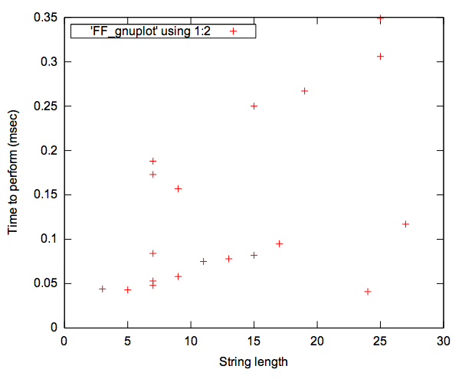
Time to perform ms
Still the same comment as 20110706Calculator and time process push.doc

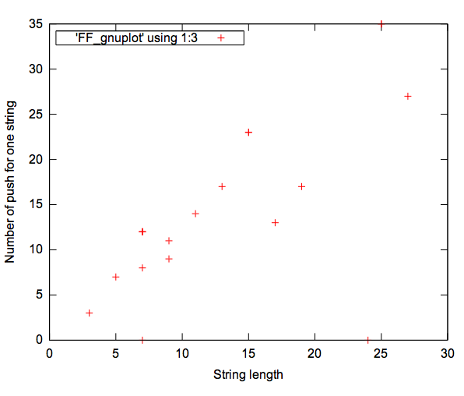
Number of push
Still the same comment as 20110706Calculator and time process push.doc

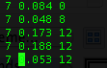
Variation with 12 pushes and time to perform are too different.

Conclusion
There is no impact in the order with if elsif else end structure.

